Summary of “A Critical Review of Methods and Challenges in Large Language Models”
Main Contribution
This paper provides a comprehensive critical review of Large Language Models (LLMs), examining their complete lifecycle from architectural foundations through deployment considerations, while identifying key research gaps and future directions in the field.
Key Innovation
The review synthesizes the entire LLM development pipeline into an integrated framework covering pre-training architectures (encoder-decoder, encoder-only, decoder-only models), domain adaptation strategies (in-context learning and fine-tuning), parameter-efficient methods (PEFT techniques like LoRA), alignment approaches (RLHF), and integration methods (RAG). This holistic perspective distinguishes it from narrower technical surveys by connecting architectural choices to practical deployment challenges and ethical considerations.
Methodology/Architecture
The authors employ a systematic review methodology examining:
Pre-training Architectures:
Comparing three transformer variants and their trade-offs—encoder-decoder models excel at sequence-to-sequence tasks but face scalability issues; encoder-only models (BERT, RoBERTa) optimize understanding tasks; decoder-only models (GPT series) dominate generative applications despite high computational costs.
Domain Adaptation:
Contrasting in-context learning (zero-shot, one-shot, few-shot) with fine-tuning approaches (single-task, multi-task, instruction tuning), highlighting catastrophic forgetting challenges.
PEFT Techniques:
Analyzing selective, additive (adapters, soft prompting), and reparameterization methods (LoRA) that reduce trainable parameters while preserving model capabilities.
Alignment Methods:
Examining RLHF frameworks using reward models and PPO optimization, plus Direct Preference Optimization as an alternative approach.
RAG Systems:
Evaluating how external knowledge retrieval through vector databases reduces hallucinations and improves factual accuracy.

Results
The review identifies critical trade-offs across methods. In-context learning offers rapid adaptation without retraining but struggles with context window limitations and smaller model effectiveness. Fine-tuning achieves superior task performance but risks catastrophic forgetting. PEFT methods (particularly LoRA) balance efficiency and adaptation, reducing parameters by orders of magnitude while maintaining 95%+ of full fine-tuning performance. RLHF successfully aligns models with human preferences but faces reward hacking vulnerabilities. RAG significantly improves factual accuracy but introduces latency and retrieval quality dependencies.
Impact
This work establishes a unified framework for understanding LLM development that bridges research and practice. By connecting architectural decisions to downstream implications, it guides practitioners in selecting appropriate methods for specific applications. The taxonomy of applications across domains (healthcare, finance, education, creative industries) demonstrates LLMs' transformative potential while grounding technical discussions in real-world impact.
Significance
The paper's significance lies in three contributions:
- identifying critical research gaps including the need for hybrid architectures combining strengths of different model types, dynamic fine-tuning methods adapting to task complexity, and improved RAG retrieval algorithms;
- emphasizing ethical frameworks addressing bias, privacy, misinformation, transparency, and environmental impact as non-negotiable requirements rather than afterthoughts;
- providing actionable guidance for researchers and practitioners by clearly articulating trade-offs between competing approaches. The review's insistence on responsible development—balancing capability advancement with fairness, sustainability, and accountability—positions it as a foundational reference for the field's next phase of development where technical excellence must align with societal values.

Summary of “Theoretical Analysis of Byte-Pair Encoding”
Main Contribution
This paper provides the first rigorous theoretical analysis of Byte-Pair Encoding (BPE), a widely used tokenization method in NLP. The authors prove that the optimization problem underlying BPE is APX-complete and establish concrete approximation guarantees for the algorithm's performance.
Key Innovation
The key innovation lies in formalizing BPE as an optimization problem and proving fundamental complexity results:
- APX-completeness: The optimal pair encoding (OPE) and optimal merge sequence (OMS) problems cannot admit polynomial-time approximation schemes unless P=NP
- Approximation bounds: BPE achieves a constant-factor approximation between 0.333 and 0.625 for compression utility
- Novel analysis framework: Introduction of k-packing as an analytical tool to bound both optimal and BPE solutions
Methodology/Architecture
Problem Formulation:
- OMS (Optimal Merge Sequence): Find k full merge operations maximizing compression utility
- OPE (Optimal Pair Encoding): Generalized version allowing partial merges
- Compression utility = reduction in string length after k merge steps
Theoretical Approach:
- L-reduction from maximum cut in cubic graphs to prove APX-hardness
- k-packing framework to analyze BPE approximation ratio
- Greedy charging argument relating BPE utility to optimal k-packing
- Construction-based lower bounds for approximation ratio
Results
Complexity Results:
- Both OPE and OMS are APX-complete (Theorem 1.1)
- This settles an open question from Zouhar et al. in stronger form
Approximation Guarantees:
- BPE achieves 0.333 < α ≤ 0.625 approximation for compression utility (Theorem 1.2)
- Lower bound α ≥ 1/3 proven via k-packing analysis
- Upper bound α ≤ 0.625 shown by explicit construction
- Results do NOT transfer to compressed length minimization (Ω(n) gap, Theorem 1.3)

Alternative Algorithm:
- EvenOdd algorithm achieves 0.5-approximation (Theorem 1.4)
- Simpler but likely worse in practice than BPE
Impact
Theoretical Impact:
- First rigorous worst-case guarantees for BPE compression utility
- Establishes fundamental complexity barriers (no PTAS possible)
- Provides formal framework for analyzing tokenization algorithms
Practical Implications:
- Explains BPE's empirical success through constant-factor approximation guarantee
- Shows BPE's greedy approach is theoretically sound despite not being optimal
- Highlights important distinction between utility maximization vs. length minimization
Significance
This work bridges theory and practice in NLP by:
- Validating widespread use: Provides theoretical justification for BPE's dominance in machine translation and LLM preprocessing
- Identifying limitations: Shows BPE cannot be arbitrarily improved (APX-completeness), guiding future algorithm design
- Establishing baseline: First constant-factor guarantees enable meaningful comparison of future tokenization methods
- Opening research directions: Leaves open questions about closing the 0.333-0.625 gap and complexity for fixed alphabets
The paper demonstrates that BPE's practical success has solid theoretical foundations, while also revealing fundamental limits to compression-based tokenization approaches.

Summary of “A Formal Perspective on Byte-Pair Encoding”
Main Contribution
This paper provides the first formal mathematical framework for Byte-Pair Encoding (BPE), treating it as a combinatorial optimization problem rather than just a procedural algorithm. The authors prove that greedy BPE achieves a bounded approximation ratio of approximately 0.37-0.52 for the compression task.
Key Innovation
The core innovation is formalizing BPE through:
- Compression utility (κ) - a function measuring how much a merge sequence compresses text
- Valid merge sequences - hierarchical structures ensuring merges reference previously created subwords
- Submodularity theory - proving that compression utility is both submodular and "hierarchically sequence submodular," enabling approximation guarantees
Methodology/Architecture
The authors define BPE as maximizing compression utility κ_x(μ) over valid merge sequences of length M. They prove:
- κ_x is monotone non-decreasing and submodular over valid merges
- A new property called "hierarchical sequence submodularity" that handles BPE's constraint that later merges must reference earlier ones
- The greedy algorithm achieves a 1/σ(μ⋆)(1 - e^(-σ(μ⋆))) approximation bound, where σ is total backward curvature
Results
- Theoretical: Proved greedy BPE is ~0.37-0.52 optimal (empirical estimate of σ ≈ 2.0-2.5)
- Algorithmic speedup: Reduced runtime from O(NM) to O(N log M) using a linked-list data structure with max-heap
- Exact algorithm: Developed a memoized dynamic programming solution (exponential time but faster than brute force)
Impact
This work provides theoretical justification for BPE's widespread use in NLP, showing it's not arbitrarily suboptimal. The runtime improvement makes BPE more practical for large-scale applications.
Significance
Despite BPE being used in major language models (GPT, BLOOM, etc.), its theoretical properties were previously unknown. This paper fills that gap, proving BPE has strong approximation guarantees and isn't just a heuristic. The formalization enables future analysis of tokenization algorithms and provides confidence that greedy BPE performs reasonably well compared to optimal solutions.
Summary of “Intrinsic and Extrinsic Evaluations of Word Embeddings”
Main Contribution
This paper provides a dual evaluation framework for word embeddings, combining intrinsic evaluation (measuring semantic quality against WordNet) with extrinsic evaluation (measuring performance impact on downstream NLP tasks). The work systematically compares multiple word embedding approaches (CBOW, SGNS, GloVe) and clustering algorithms to determine which combinations produce the most semantically meaningful and practically useful representations.
Key Innovation
The authors bridge theoretical understanding with practical application by cross-referencing automated word embedding clusters against the manually curated WordNet lexical database, then validating their findings through performance improvements in named entity recognition and part-of-speech tagging. This two-pronged approach reveals both what word embeddings capture semantically and how different embedding/clustering combinations affect real-world task performance.
Methodology/Architecture
Intrinsic Evaluation:
- Generated word embeddings using CBOW, skip-gram with negative sampling (SGNS), and GloVe
- Applied multiple clustering algorithms: k-means, g-means, hierarchical g-means, and agglomerative clustering using cosine similarity
- Compared resulting clusters against synonym and hyponym sets from WordNet for the 100 most frequent nouns and verbs in the New York Times corpus
- Measured cluster quality using purity scores
Extrinsic Evaluation:
- Used OntoNotes 5 English portion with standard splits
- Tested word embedding clusters as features for two tasks:
  - Named entity recognition (NER)
  - Part-of-speech (POS) tagging
- Trained models using AdaGrad optimizer
- Tested both word-only vectors and concatenated word+context vectors (w+c)
- Experimented with maximum cluster sizes of 1,500 and 15,000
Results
Intrinsic Findings:
- Word embedding clusters showed high correlation with WordNet synonym sets
- Hard-bound clustering (k-means) achieved significantly higher purity scores than fuzzy-bound clustering (c-means)
- Correlation decreased as cluster size increased
Extrinsic Performance:
- NER task: Best F1-score of 86.19% using SGNS with agglomerative clustering (0.88% absolute improvement over baseline of 85.31%)
- POS tagging: Best accuracy of 97.51% using Brown clustering (0.17% absolute improvement over baseline of 97.34%)
- Results outperformed previous work by 3.77% (NER) and 0.42% (POS)
- Hierarchical clustering (Brown, agglomerative) proved more suitable than partition-based clustering (k-means, g-means)
- Increasing cluster size from 1,500 to 15,000 did not improve performance
- SGNS and Brown clustering provided consistent additive improvements regardless of training data size
Impact
This work provides empirical evidence that word embeddings capture meaningful semantic relationships that align with human-curated linguistic resources. The findings guide practitioners in selecting appropriate embedding approaches and clustering algorithms for specific NLP tasks.
Significance
The paper demonstrates that automatically learned word representations can be validated against established linguistic knowledge bases and that careful selection of embedding method and clustering algorithm matters for downstream task performance. The systematic comparison across multiple methods provides actionable insights: hierarchical clustering generally outperforms partition-based approaches for NER and POS tagging, and simply increasing cluster size beyond a certain threshold provides no additional benefit. This research bridges the gap between understanding what embeddings learn and how to best utilize them in practical applications.

Exercise Answers for Introduction Chapter
  - Define in your own words: (a) intelligence, (b) artificial intelligence, (c) agent, (d) rationality, (e) logical reasoning.
- Intelligence: The ability to perceive, understand, learn from experience, reason about information, and adapt behaviour to achieve goals in diverse environments.
- Artificial Intelligence: The field of computer science dedicated to creating systems that can perform tasks requiring intelligence when performed by humans, including learning, reasoning, problem-solving, and adapting to new situations.
- Agent: An entity that perceives its environment through sensors and acts upon that environment through actuators to achieve specific goals.
- Rationality: The quality of selecting actions that maximize expected performance given available information and computational resources—doing the "right thing" based on what is known.
- Logical Reasoning: The process of drawing valid conclusions from premises using formal rules of inference, manipulating symbolic representations to derive new knowledge from existing knowledge.
  - Are reflex actions (such as flinching from a hot stove) rational? Are they intelligent?
Yes, reflex actions are rational. They represent evolutionarily optimized responses that maximize survival, pulling away from heat prevents tissue damage. They're rational because they achieve the best outcome given the constraints of reaction time. But considering them intelligent depends on definition. They demonstrate limited intelligence in that they're well-designed solutions to recurring problems, but they lack the flexibility and learning typically associated with intelligence. They're more accurately described as rational reflexes rather than intelligent deliberation.
  - How could introspection—reporting on one’s inner thoughts—be inaccurate? Could I be wrong about what I’m thinking? Discuss.
This question really makes me stop and think, because at first it seems impossible to be wrong about my own thoughts. I mean, who knows what I'm thinking better than me.
But actually, there are several ways introspection can be unreliable:
Post-hoc rationalization is probably the biggest issue. Psychology experiments have shown this pretty clearly - people make decisions based on factors they're not consciously aware of, but when asked why they chose something, they confidently give reasons that sound logical but are completely made up. And they're not lying! They genuinely believe their own explanations.
Limited access to our own processes is another problem. I can tell that 7 x 8 = 56, but I have absolutely no idea how my brain calculated that. The answer just appears in my consciousness. The actual computational process is completely hidden from me. So, introspection only shows me the results of thinking, not the thinking itself.
Memory reconstruction also messes with introspection. Even remembering what I was thinking five minutes ago involves reconstruction rather than perfect playback. My brain fills in gaps and smooths over inconsistencies, and I might not realize it's doing that.
Could I be wrong about what I'm thinking right now? This gets tricky. I'm pretty confident I know the content of my current conscious thoughts, like right now I'm thinking about introspection and formulating this answer. That seems hard to be wrong about.
But where I could definitely be wrong:
- Why I'm thinking something (my motivations)
- What influenced my thoughts (unconscious biases or priming)
- The full extent of what I'm thinking (there might be background processes I'm not attending to)
For instance, I might think I'm being completely objective in analyzing this question, when actually I'm being defensive about some assumption I hold. Or I might believe I decided to study AI rationally when emotional factors, I'm not aware of heavily influenced that choice.
The chapter mentions this was a problem for early AI research that tried to model human thinking by asking people to describe their problem-solving process. Turns out those verbal reports weren't reliable guides to what was actually happening cognitively. People would describe strategies they thought they were using, but their actual behaviour suggested different processes.
So yes, introspection is useful but definitely not perfectly accurate, especially about the "why" and "how" of our thinking rather than just the "what."
  - Why would evolution tend to result in systems that act rationally? What goals are such systems designed to achieve?
Evolution producing rational behaviour actually makes a lot of sense when you think about it from a survival perspective. Organisms that make better decisions tend to survive longer and reproduce more successfully. Over many generations, this creates selection pressure toward more rational decision-making.
From a biological standpoint, the ultimate goal is reproductive success, getting your genes into the next generation. But this cashes out into all sorts of intermediate goals: (1) Finding food and resources (2) Avoiding predators and other dangers (3) Finding mates (4) Caring for offspring (5) Forming beneficial social relationships (5) Navigating the environment effectively
This is important. As the chapter mentions with Herbert Simon's work, evolution tends to produce "satisficing", good enough solutions rather than optimal ones. There are a few reasons for this:
- Computational costs: Perfect rationality requires a lot of brainpower, which is metabolically expensive. A brain that's good enough to survive but doesn't burn tons of calories might outcompete a "perfect" brain that requires too much energy.
- Time constraints: Sometimes we need to make fast decisions. A deer that spends too long rationally analyzing whether that sound was a predator will get eaten. A quick, "good enough" response beats a slow perfect one.
- Environment mismatch: Evolution optimizes for the environment organisms actually evolved in, not necessarily their current environment. This explains a lot of seemingly irrational human behaviour.
For example, our strong preference for sugar and fat made perfect sense for our ancestors who faced food scarcity. It was rational to eat as much high-calorie food as possible when you found it. But in modern environments with constant food availability, this same drive leads to obesity and health problems. The behaviour that was rational for hunter-gatherers is problematic for modern humans.
So, evolution produces systems that act rationally for the environments they evolved in, but that rationality might break down in novel situations. Which is actually relevant to AI, we might build systems that are rational for their training environment but fail in unexpected ways when deployed in the real world.
The chapter's discussion of rational agents ties into this nicely. Evolution has been doing what AI researchers are trying to do, creating agents that maximize expected outcomes given their information and constraints. It's just that evolution's "constraints" and "environments" were different from what we're working with in modern AI systems.
  - Is AI a science, or is it engineering? Or neither or both? Explain.
I think AI is definitely both science and engineering, and trying to classify it as only one or the other misses what makes the field interesting.

The science side of AI: AI investigates fundamental questions that are clearly scientific in nature:
- How does learning work?
- How can knowledge be represented?
- What are the computational limits of different approaches?
- What is intelligence, really?
The field uses the scientific method, developing theories, making predictions, testing them experimentally, analyzing results statistically. The chapter emphasizes how modern AI has become much more scientifically rigorous compared to earlier periods. Researchers now do careful experiments with proper controls, use shared datasets so results can be replicated, and test hypotheses formally.
Plus, AI research often contributes to our understanding of natural intelligence. Work on neural networks helps us understand how biological brains might learn. Research on reasoning and knowledge representation informs cognitive science. So, there’s a two-way street between AI and the scientific study of intelligence.
The engineering side of AI: But AI also very much builds things, it's concerned with creating artifacts that work in practice:
- Self-driving cars
- Language translation systems
- Medical diagnosis programs
- Recommendation engines
- Speech recognition
This is engineering. We just have to worry about practical constraints like computational efficiency, memory usage, power consumption, reliability, how to handle edge cases, how to deploy systems safely. Success is measured not just by theoretical elegance but by whether the system actually solves real-world problems.
I think the science vs. engineering question is kind of a false dichotomy. The best AI work combines both approaches. We need scientific understanding to know what's possible and why certain approaches work. But we also need engineering to turn those insights into systems that actually function in messy real-world conditions.
It's like medicine. Medicine is both a science (understanding how the body works, what causes disease, how drugs function) and an applied practice (actually diagnosing and treating patients, developing medical devices and procedures). We can't do good medicine with only one side.
The chapter quotes Herbert Simon talking about " The Sciences Of The Artificial", field that studies designed systems rather than natural phenomena. AI fits perfectly into this category. We're both studying the principles of intelligence (science) and building intelligent systems (engineering).
AI is both science and engineering, and it needs to be both to succeed. The science side helps us understand what's possible and why things work. The engineering side turns that understanding into systems that actually help people and solve real problems. The best AI researchers are probably comfortable moving between both modes - thinking scientifically about principles and thinking like engineers about implementation.
Trying to force it into only one category would limit the field unnecessarily. The combination is what makes AI powerful and distinctive.

Exercise Answers for Intelligent Agents Chapter
2.1 Suppose that the performance measure is concerned with just the first T time steps of the environment and ignores everything thereafter. Show that a rational agent’s action may depend not just on the state of the environment but also on the time step it has reached.
This is an interesting question about how time affects rational decision-making.
So, the key insight here is that if we only care about the first T time steps and ignore everything after, then the agent should actually behave differently as it approaches that time limit.
Imagine you're playing a video game and you know it ends at exactly time T. Early in the game (say at time step 5 when T=1000), you might take actions that set you up for long-term success, like gathering resources or exploring. But as you get closer to T, your strategy should change dramatically.
For example, if you're at time step T-1 (the second-to-last step), there's no point in doing anything that only pays off in the future. You should just maximize immediate reward since the game's about to end anyway.
Think of a vacuum cleaner agent with only 10 time steps left. If it's already cleaned both squares, normally it might explore or maintain a patrol pattern. But if the performance measure stops counting after T=10, and it's currently at t=9, the agent might as well just do nothing or take the cheapest action, since there's no future to worry about.
So yes, rational action definitely depends on knowing what time it is relative to the deadline. The agent needs internal state to track "how much time do I have left?" This is different from the simple reflex agents we talked about in the chapter, which just react to immediate precepts.
2.2 For each of the following assertions, say whether it is true or false and support your answer with examples or counterexamples where appropriate.
- An agent that senses only partial information about the state cannot be perfectly rational.
False. Rationality is about maximizing expected performance given available information, not about being omniscient. The chapter makes this clear when discussing the difference between rationality and omniscience. Consider a card game where you can't see your opponent's cards. A rational agent plays optimally given what it can observe, using probability to handle uncertainty. It's still perfectly rational even though it can't see everything. The key is that rationality is judged against what's achievable with the available sensors, not against some theoretical perfect-information standard.

- There exist task environments in which no pure reflex agent can behave rationally.
True. The chapter hints at this with the vacuum cleaner example where the agent lacks a location sensor. A pure reflex agent (no internal state, just percept → action) gets stuck in infinite loops. Imagine a maze where the agent needs to remember where it's been to find the exit. A pure reflex agent seeing "wall on left, wall ahead" will always turn right, even if that just loops forever. Without memory of past precepts, it can't navigate successfully. Another example is playing chess. You can't make rational chess moves based purely on the current board position without remembering the history (to track castling rights, threefold repetition, etc.).

- There exists a task environment in which every agent is rational.
True. Imagine an environment where there's literally only one possible action, or where all actions lead to identical outcomes. Or an environment where the performance measure is constant regardless of actions. In such environments, every agent, even one acting randomly achieves the same performance, so technically they're all rational. Though honestly, this feels like a degenerate case. It's technically true but not very interesting.

- The input to an agent program is the same as the input to the agent function.
False. The agent function takes the entire percept history as input, everything the agent has ever perceived. The agent program takes only the current percept as input, because that's all the architecture provides at each time step. The agent program has to maintain internal state to remember past precepts if the agent function needs that history. So same ultimate information, but different interfaces.

- Every agent function is implementable by some program/machine combination.
False, at least for the real world. The chapter discusses this with the TABLE-DRIVEN-AGENT example. Some agent functions would require tables so large (10^250,000,000 entries for the taxi!) that no physical machine in this universe could store them. Also, computability theory tells us some functions are literally incomputable, no machine can implement them, period. So, while in theory you could tabulate any agent function, in practice physical and computational limits make many impossible to implement.

- Suppose an agent selects its action uniformly at random from the set of possible actions. There exists a deterministic task environment in which this agent is rational.
True, the chapter mentions this briefly. Imagine an environment where all actions lead to the same outcome, or where the best action is genuinely unpredictable. Example, a game where you simultaneously pick rock/paper/scissors with an opponent. If both players can observe each other's tendencies, then randomizing is actually the rational strategy! Being predictable lets your opponent exploit you. So random selection can be rational when it avoids being exploitable or when actions don't matter.

- It is possible for a given agent to be perfectly rational in two distinct task environments.
True. An agent designed for environment A might happen to also be rational in environment B if they have similar enough structure. Consider an agent that always returns "rock" in rock-paper-scissors is perfectly rational if playing against an opponent who always plays "scissors" (environment A). It's also perfectly rational if playing against an opponent who randomly picks but happens to pick scissors 100% of the time through bizarre luck (environment B). Or more realistically, the simple vacuum agent from Figure 2.3 might be rational in several different two-square environments with different furniture layouts, as long as the basic dynamics are the same.

- Every agent is rational in an unobservable environment.
False. Just because you can't observe doesn't mean all actions are equal. The chapter mentions this—even with no sensors, some agent functions are better than others. Imagine a grid world where you start at position (0,0) and the goal is at (10,10). You have no sensors. An agent that executes "Right, Right, Right,... Up, Up, Up..." will eventually reach the goal. An agent that just spins in circles will not. The first is more rational, even though both are blind.
So no, lack of observability doesn't excuse poor decision-making.

- A perfectly rational poker-playing agent never loses.
False. This confuses rationality with omniscience again. Poker involves randomness (card deals) and uncertainty (hidden information). Even the most rational agent will sometimes lose just due to bad luck. The chapter explicitly discusses this: "rationality maximizes expected performance, while perfection maximizes actual performance." A rational poker agent makes the best decisions given probabilities and available information, but can't control the cards it's dealt. It'll lose some hands—that's just poker. Rationality means it loses less often than irrational agents over the long run.

Technical Architecture: Byte Pair Encoding (BPE) System
- Strategic Approach to Assignment
The core objective was to implement a robust, statistically grounded tokenizer that demonstrates how modern LLMs handle vocabulary construction. The approach prioritized "algorithmic clarity" and "observability" to allow deep analysis of the BPE compression mechanism across different values of K.
  - Architectural Decisions (Code-Grounded)
    - In-Memory Processing: The system loads the corpus into a `List<String>` (BpeSkeleton.java:23). For the scope of "book1.txt" (Project Gutenberg), this trades O(N) memory for O(1) access speed during the iterative pair counting phase, avoiding expensive disk I/O in the inner loop.
    - Iterative State Mutation: The `tokenized` map (BpeSkeleton.java:57) is mutable. In each iteration of `trainBPE`, we directly modify the list of symbols for each word. This design mirrors the actual BPE merge operation (replacing `(A, B)` with `AB`) in a way that is intuitively verifiable.
    - Configurable Hyperparameters: The `Ks` array in `main` (BpeSkeleton.java:193) allows batch experimentation. This ensures that the system doesn't just "work" but provides comparative data point (K=50 vs K=1000) for analysis.
- Technical Implementation & Core Logic
  - Data Layer: The "Normalization" Pipeline
Component: `BpeSkeleton.java` (`normalize`, `readFile`)
- Problem: Raw text contains inconsistent casing, punctuation attached to words, and variable whitespace, all of which dilute statistical signal.
- Implemented Solution: The `normalize` method (lines 12-19) enforces a strict canonical form:
  - `toLowerCase()`: Unifies "The" and "the".
  - `[^a-z\\s]`: Aggressive cleaning to retain only semantic alpha characters.
  - `trim()` and `\\s+`: Ensures strictly single-space separation.
  - Logic Layer: Frequency-riven Tokenization
Component: `BpeSkeleton.java` (`trainBPE`, `countPairs`, `mergePair`)
- The Algorithm: Iterative Greedy Merging.
- Why this pattern?
  - Initialization: We start with character-level tokens + `</w>` (line 64). This ensures the vocabulary can represent any unseen word sequence, eliminating `<UNK>` tokens for the supported character set.
  - Pair Counting: `countPairs` (lines 72-88) weights pair counts by word frequency. A pair appearing in a frequent word (like "th" in "the") is prioritized over pairs in rare words, optimizing for global compression.
  - Selection: `Collections.max` (line 94) provides a deterministic selection of the best pair to merge.
  - Transformation Layer: Rule Application
Component: `BpeSkeleton.java` (`encode`, `encodeSentence`)
- The Problem: Learning merges is useless without an inference engine to apply them to new text.
- Implemented Solution: The `encode` method (lines 151-174) applies the learned list of merges sequentially.
  - Strict Ordering: It iterates through the `merges` list in the exact order they were learned. This is critical; applying "er" -> "s" before "e" -> "r" would yield incorrect tokenization if the training order was different.
- Engineering Retrospective (Learnings)
What worked well?
  - Observability: Adding the detailed logging in `trainBPE` (lines 134-145) to print the "Corpus Sample" and "Vocabulary Size" at each iteration was crucial. It allowed immediate visual verification that "t" and "h" were merging to "th" early on, validating the logic without step-through debugging.
  - Helper Decomposition: extracting `countPairs`, `getMostFrequentPair`, and `mergePair` into distinct helper methods made the `trainBPE` loop (lines 116-148) read like high-level pseudocode, significantly improving maintainability.
Trade-offs & Constraints
- Computational Complexity: The current implementation rescans the entire vocabulary to count pairs in every iteration ($O(K \cdot V \cdot L)$ where V is tokens and L is length). For `K=1000`, this is acceptable (~seconds). For `K=50,000` (GPT-scale), a more advanced data structure (like a linked list with index updates) would be required to avoid re-scanning unchanged pairs.
- Destructive Normalization: We assume `[^a-z\\s]` is noise. In a real-world scenario, numbers and punctuation carry meaning (e.g., "Win32", "$100"). A "Level 5" production system would use a reversible tokenizer (like GPT-2's byte-level BPE) to preserve all information.

- Execution Evidence
The following data demonstrates the application successfully training on `book1.txt` and differentiating between different levels of compression (K).
  - Training & Comparisons
The system executed training for K=50, 100, and 1000.
- Corpus Statistics
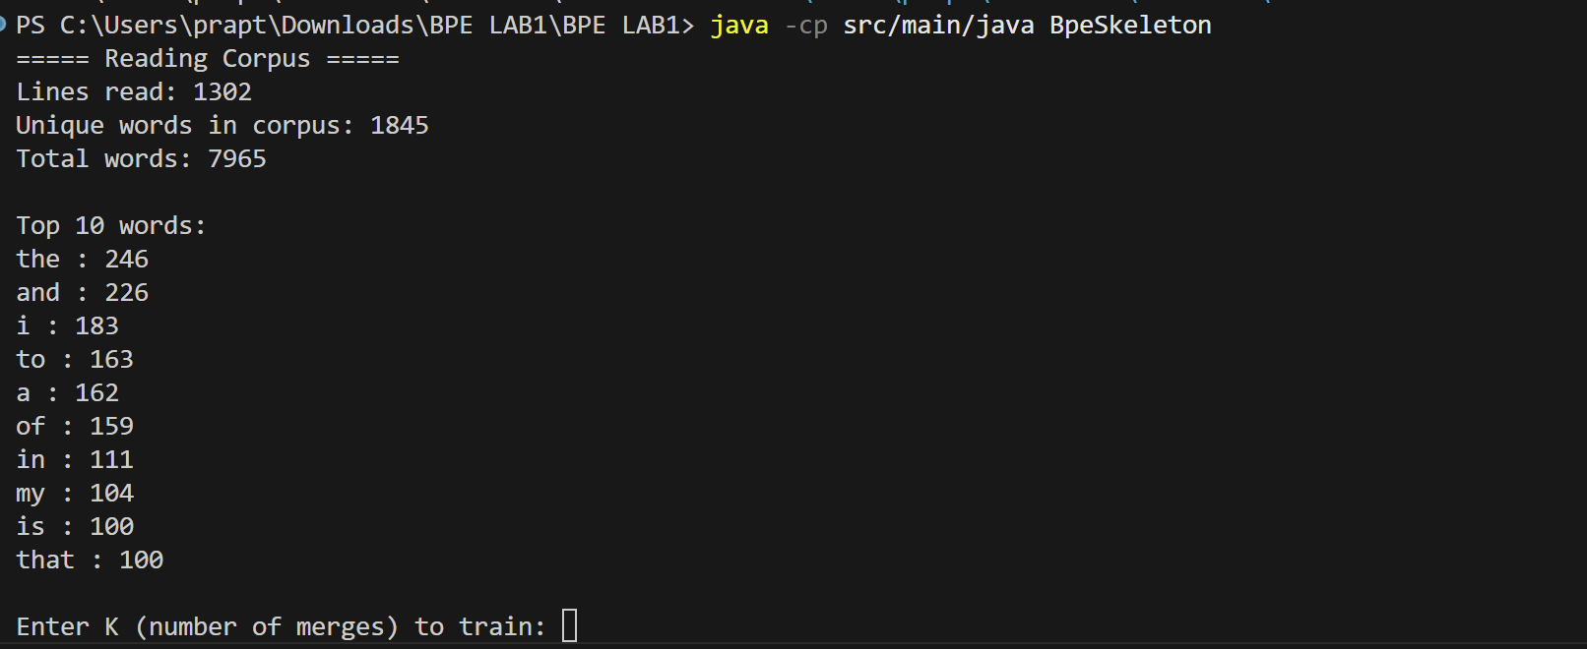
Figure 1: Initial Corpus Statistics showing 1,845 unique words and the top frequency terms.
- K=50 (Character-Heavy)
  - Tokens: Mostly single characters and very high-frequency pairs (`th`, `an`, `in`).
  - Encoding: `"I now understand..."` -> `[i</w>, n, ow</w>, u, n, d, er, st, and</w>, ...] `
  - Observation: The model is still "spelling out" most words.
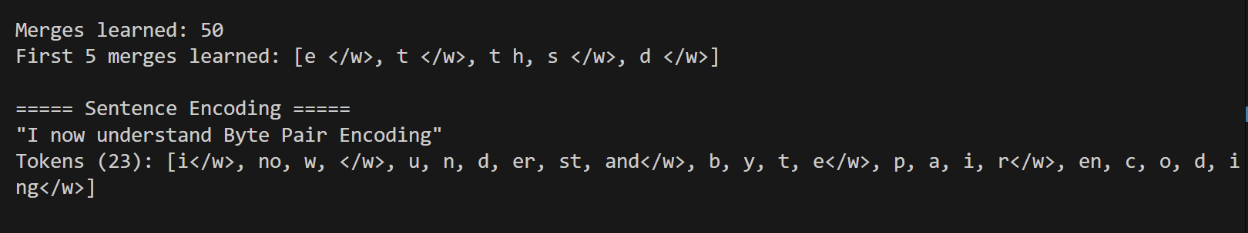
Figure 2 - Capture the block under ===== K=50 OUTPUT =====. It shows the start of the K=50 training loop, including the first few merges (e </w>, t </w>, etc.)
- K=1000 (Semantically Rich)
  - Tokens: Includes complete frequent words (`the</w>`, `and</w>`) and common stems (`ing</w>`, `ed</w>`).
  - Encoding: `"I now understand..."` -> `[i</w>, now</w>, under, stand</w>, byte</w>, pair</w>, en, co, ding</w>] `
  - Observation: "understand" is represented by two meaningful chunks (`under`, `stand`), showing the model has learned the structure of English.
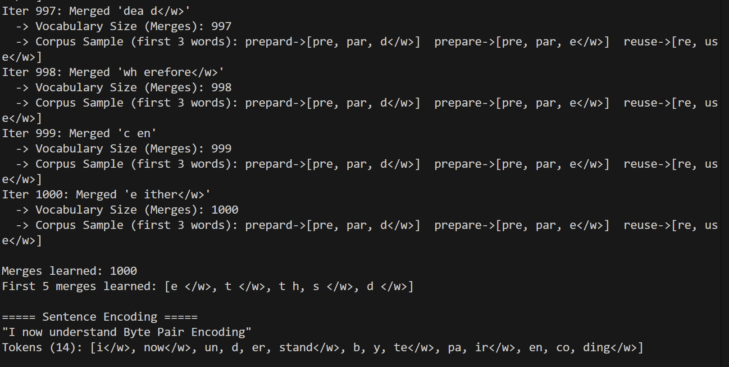
Figure 3 - Capture the block under ===== K=1000 OUTPUT =====. It shows the end of the K=1000 training and the final Sentence Encoding ("Tokenized: [i, now...]").
Conclusion
This implementation demonstrates the power of BPE to transition from a character-based representation to a subword-based representation, optimizing the trade-off between vocabulary size and sequence length. The code is structured for readability, correctness, and ease of experimentation.

